

District 6580 Multi-Year Strategic Plan

October 22, 2022

Summary of Outcomes

District 6580

Goals and Vision

2017-2019

**Rotary Foundation**

* **Coordinate a District Global Grant – multiple clubs coming together (12)**

**-Cooperative with another district**

**-do a project outside of club’s community**

**-small contribution per club ($1,000?)**

**-Tap Heart2Heart as possible participating district**

**-Invite Ron Appuhn to district conference or a meeting**

* Expand the Foundation team to include a storyteller/writer

**Public Image**

* Establish goals, job descriptions tools for the district Public Image Chair and committee (5)
* Find a District Public Image leader (2)
* **Train club Public Image Chairs once they are appointed (13)**

**-Brand guidelines**

**-Webinar? Conference? Assembly?**

**-Share the info/People of Action**

**-target clubs’ own members and their communities**

**-teach storytelling and Calls to Action**

**Grow Rotary**

* Reach out to former members to -re-engage (1)
* Explore technology options for membership promotions
* Talk more about engaging members (3)

-how to teach chubs

-give a sense of belonging & community

* **Encourage and promote different types of members based on life changes or stages, such as:**

**-children -retirement (12)**

* Start preparing for post-millennials – They like face-to-face interaction – Develop the ASK – Tap Interact and Rotaract
* Engage millennials – go to them – social media – their roads to service – joint meetings with young leaders’ groups – use new terms for them (NOT Millennials – young members) – be more inclusive (3)
* **Encourage clubs to “grow” – new clubs – satellite club – retirement communities – help clubs identify past members (11)**
* Form new clubs in non-Rotary communities (1)
* Track/reengage former Interactors (2)
* Find a way to recruit/transition Rotaractors into Rotary

**District Leadership**

* Succession plan for district chairs
* Identify/ask younger Rotarians and future leaders to attend District Conferences (8)

-use the district grant

* Use a fall Assembly as leadership development for President elects and nominees (7)
* Market PETS to clubs to send their Presidents Nominees (3)
* Empower AGs to do more visits, more club support

-easy way to do this

* Incentivize new members to attend District Conference

-give presidents tools

* Give Presidents and President Elects together periodically

**Training**

* District Assembly (7)
* Encourage RLI to be built in to club budgets (5)
* Make current webinars stronger (DacDb, My Rotary, Grants) (7)
* -add a webinar on finding grant projects
* **Help clubs set 4 times a year to have a Rotary program – like “snow days” (16)**

**-provide ideas, info, handouts and topics**

**-encourage at PETS**

* AG training 2.0 – expand on training in a 3-year rotation (3)

District 6580

New Goals & Vision

2023-2025

**Grow Rotary**

* **Promote RLI as a way to educate new members (14)**
* **Develop a district-wide new member orientation (14)**
* **Continuing the Attraction & Engagement program (12)**
* **Need to work on Growing Club & District Leadership & Committee Bench (11)**
* Interact conference focused on leadership development (10)
* Develop mindset we are a membership-based organization that focuses on service (10)
* Training on multi-generational awareness: understanding each (7)
* Quarterly membership calls with club membership chairs and/or presidents.
* Continue Rotary Roundtables
* Need to meet members where they are & encourage alternate meeting times or start satellite clubs
* Develop a committee to explore areas where Rotary is underserved
* Encourage & collaborate more with Rotaract
* Have DEI & Youth Development recognition awards.

**Training**

* **Develop incentives to attend District Conference & have programs on leadership development (14)**
* **Develop new member orientation (13)**
* **Stress assistant governor training at PETS, Zone, RLI & develop a district budget for the training (14)**
* **RLI 1 & 2 Virtual and 3 is in person at district conference (11)**
* **DEI training (10)**
* **Encourage Emerging Leaders participation at Zone Institute (8)**
* Training district Rotarians to be visioning facilitators

**District Leadership**

* **Succession planning for district chairs (15)**
* **Incorporate DEI in leadership training (13)**
* Involve Rotaract (10)
* Succession planning for club leadership with & encourage clubs to appoint PEN’s (8)
* Use Fall Assembly as a way to develop district and club leadership (6)
* Continue to have/enhance ERL track & have an abbreviated session at District Conference (6)
* Help A/G’s make more impactful connections with their clubs

**Rotary Foundation**

* **Increase Paul Harris Society (14)**
* **Incentivize awareness of Foundation through new ideas and fun (9)**
* Annual fund giving by 2026 is $250,000 (9)
* **Give club members a reason to give to TRF through storytelling and education (9)**
* Encourage reaching out to groups that have gone to areas that need help & develop future Global Grants

**Public Image**

* **Make the Tools available to all club PI chairs (17)**

**-Brand guidelines**

**-Brand Center Training**

* **Train PI chairs once they are appointed (16)**

**-Outline goals**

**-Develop Job Description**

**-Webinar? Conference? Assembly?**

**- Teach storytelling & Calls to action**

* Develop District PI calendar (13)
* Learning center for PI (8)

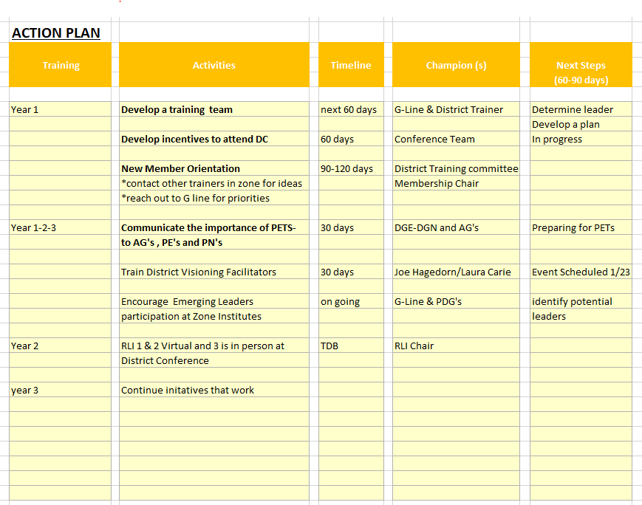

Rotary District 6580 Multi-Year Planning Session Update October 22, 2022

Key Initiatives & Timelines, Years 103

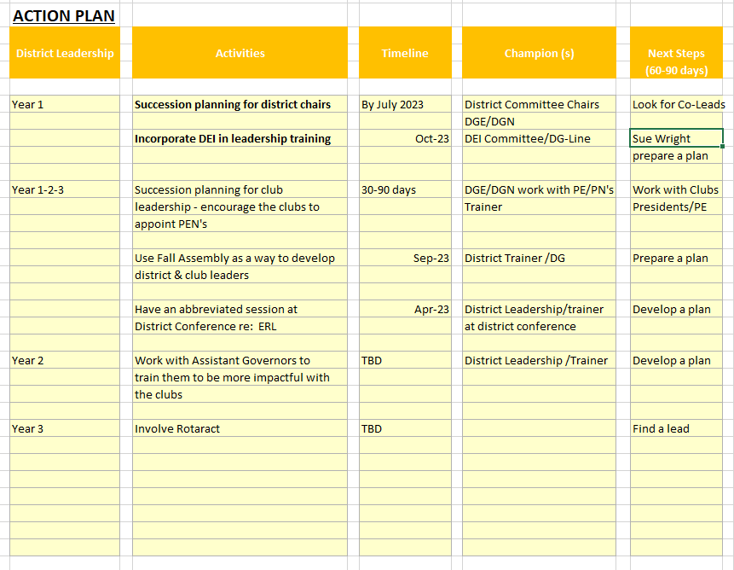

Rotary District 6580 Multi-Year Planning Session Update October 22, 2022

Key Initiatives & Timelines, Years 1-3

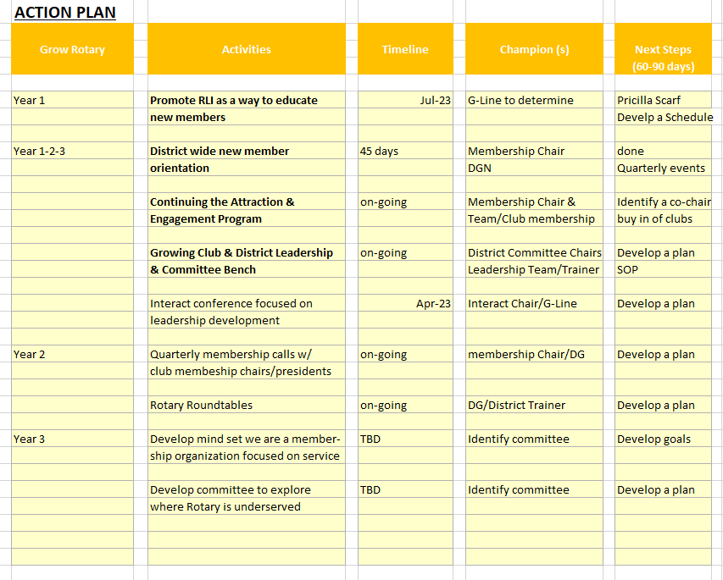

Rotary District 6580 Multi-Year Planning Session Update October 22, 2022

Key Initiatives & Timelines, Years 1-3

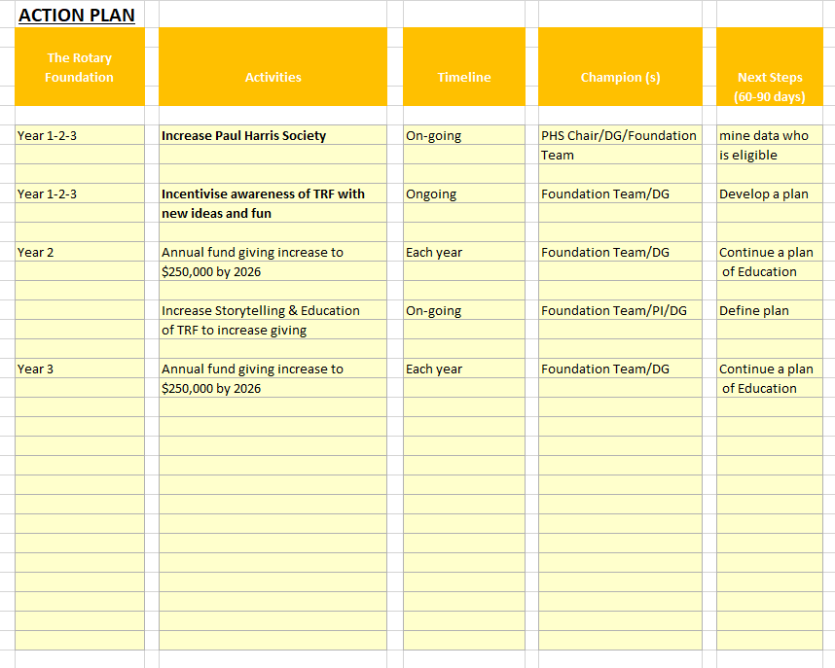

Rotary District 6580 Multi-Year Planning Session Update October 22, 2022

Key Initiatives & Timelines, Years 1-3

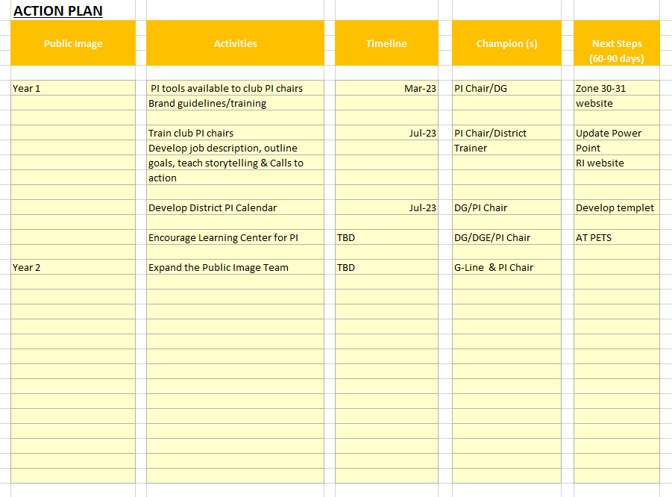

Rotary District 6580 Multi-Year Planning Session Update October 22,2022

Key Initiatives & Timelines, Years 1-3



**Facilitator’s Notes:**

* A concern is you will need more time to prepare a plan of action on all of these ideas. Do not feel defeated if you get off schedule.
* You may need to bring more Rotarians in the planning phase. It is imperative you use your District Chairs and Committees. This will give you a broader perspective on how to proceed.
* We would encourage you to reach out to additional Districts within Zone 30-31 to see if they have developed successful programs and not be afraid to take advantage of their accomplishments and learn from their failures.
* Some of your ideas and initiatives might be more successful if you target clubs that would be willing to be a pilot. Having a club willing to try a new initiative would have a better chance of success.

[This Photo](https://pt.wikipedia.org/wiki/Rotary_International) by Unknown Author is licensed under [CC BY-SA](https://creativecommons.org/licenses/by-sa/3.0/)

**What could go wrong?**

* No follow-up
* Lack of flexibility
* Not communicating with the District/Clubs
* No ownership
* Not broadening your teams

**Keep this in mind!**

* Develop a fair timeline
* Leaders need to continue talking about the plan
* Champion update leadership quarterly
* Discuss the plan at District Conference/Assembly with the club and district Rotarians
* Replace team members if not performing